Secrets Manager
What is AWS Secrets Manager?
AWS Secrets Manager is a service used to securely store, manage, retrieve, and automatically rotate secrets such as:
- Database passwords
- API keys
- SSH keys
- Tokens
- Application credentials
Instead of hardcoding passwords in your application, you store them in Secrets Manager.
Components
Component | Description
Secret | Password, API key, token
KMS | Encrypts the secret
IAM | Controls access
Rotation | Automatically changes passwords
Version | Tracks secret updates

Features
- Secure secret storage
- KMS encryption
- Automatic rotation
- IAM access control
- CloudTrail auditing
- High availability

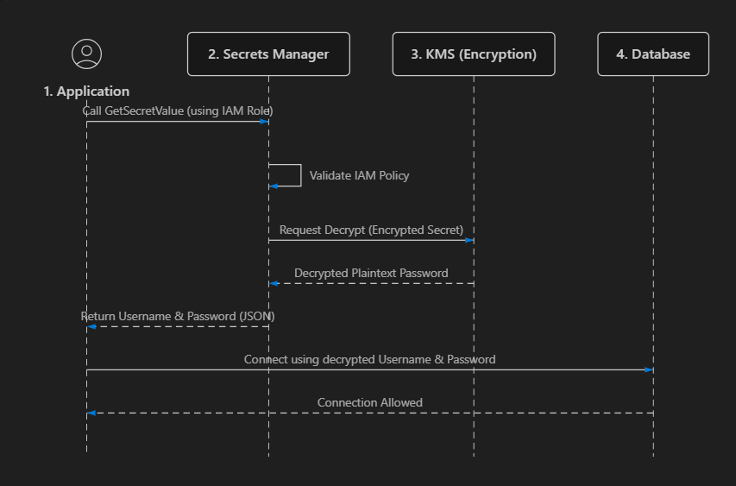
How it works:
- Get Secret: The App requests the secret value from AWS Secrets Manager.
- Decrypt: Secrets Manager stores secrets encrypted. It sends the encrypted password to AWS KMS (Key Management Service) to decrypt it.
- Return & Connect: Secrets Manager sends the plaintext password to the App. The App uses it to establish a direct connection to the Database.
- Cache (Important): The App caches the password in memory so it doesn’t have to call Secrets Manager for every single database query.

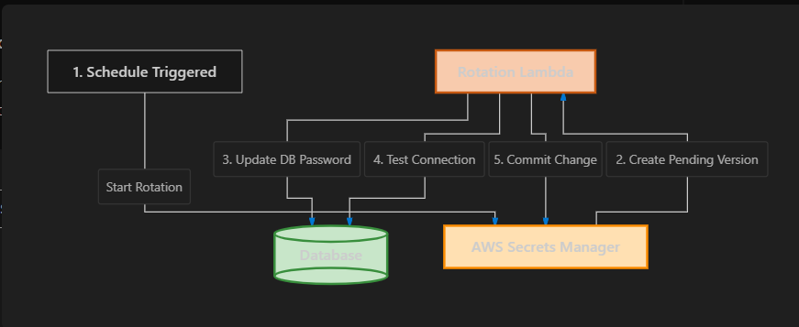

How it works (The 4-step process):
- Create Secret (AWSPENDING): Secrets Manager generates a brand new random password and marks it as AWSPENDING (not active yet).
- Set Secret in Database: The Lambda function logs into the database (using the old password) and updates the database user's password to the new AWSPENDING password.
- Test Secret: The Lambda function tries to log into the database using the new AWSPENDING password. If it works, it reports success.
- Promote Secret (AWSCURRENT): Secrets Manager swaps the label. The AWSPENDING password becomes the active AWSCURRENT password.
TIP
Application Resilience: If your application is cached in memory and the database suddenly rejects its connection (because the password rotated), the application should catch that error, clear its cache, request the new AWSCURRENT secret from Secrets Manager, and reconnect.

AWS Secrets Manager Pricing (Presentation)
Official Pricing: AWS Secrets Manager Pricing
AWS Secrets Manager follows a pay-as-you-go pricing model.
You are charged mainly for two things:
- Number of secrets stored
- Number of API calls made
There are no upfront costs or long-term commitments.

1. Cost per Secret
AWS charges:
- $0.40 per secret per month (in most AWS Regions).
Example
If you store:
- 1 database password
- 1 API key
- 1 OAuth token
Total secrets = 3
Monthly cost:
3 × $0.40 = $1.20/month

2. API Request Charges
AWS also charges for API operations such as:
- GetSecretValue
- CreateSecret
- UpdateSecret
- DescribeSecret
Price:
- $0.05 per 10,000 API calls.
Example
Suppose your application retrieves a secret 50,000 times in one month.
Calculation:
50,000 API calls

= 5 × 10,000

5 × $0.05 = $0.25

AWS Secrets Manager Hands-on Labs
Hands-on 1:
Create a Secret
Step 1: AWS Console → Secrets Manager
Step 2: Click Store a new secret
Step 3: Select Other type of secret
Step 4
Add:
Key | Value
username | admin
password | Welcome@123
Step 5: Encryption Key → aws/secretsmanager (Default)
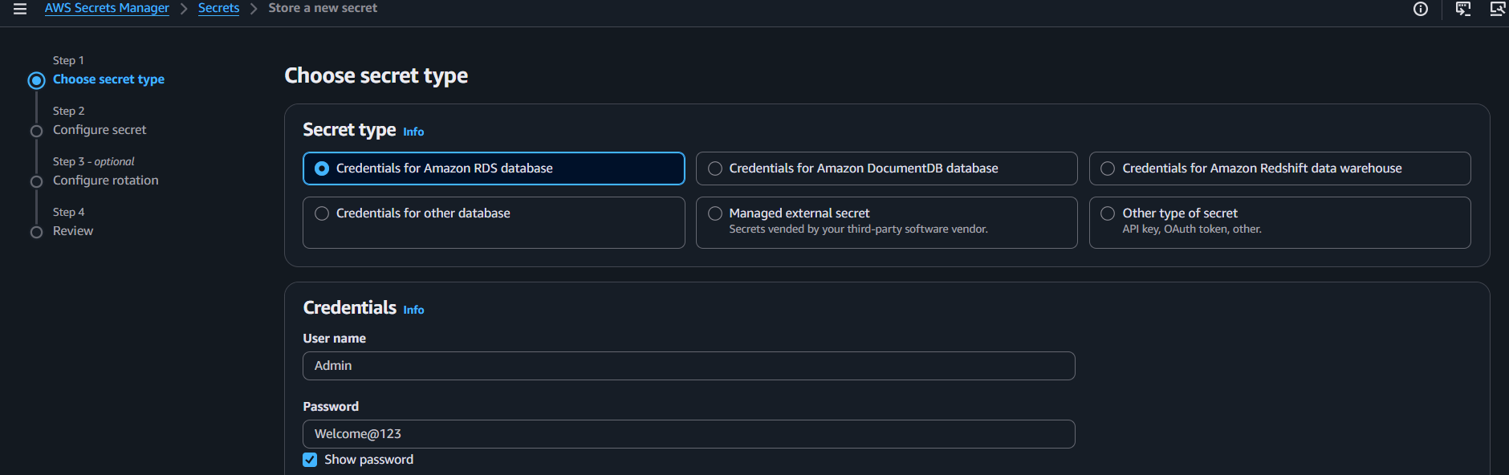
Step 6: Secret name:
my-db-secret
Step 7: Rotation → Disable
Step 8
Click Stor
✅ Secret created.
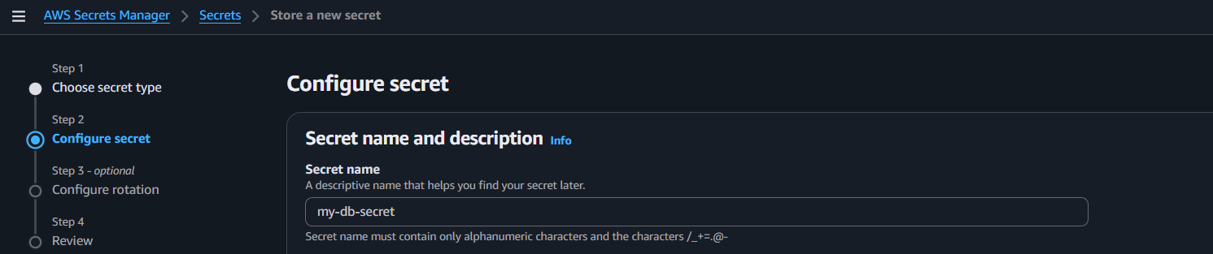

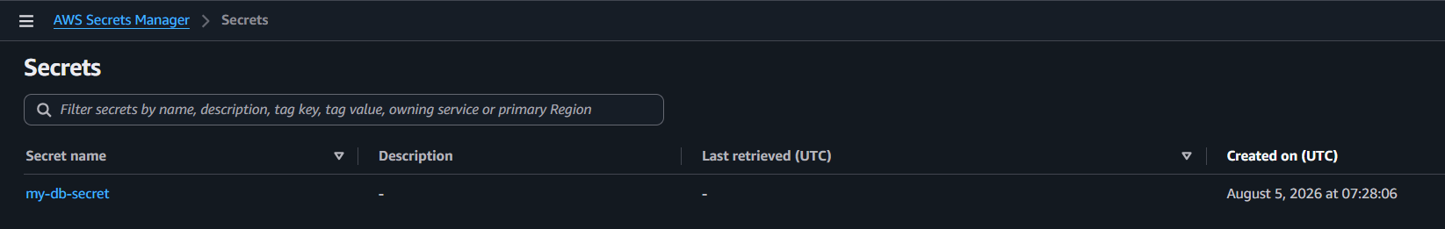

Hands-on 2:
View Secret
- Open my-db-secret
- Click Retrieve secret value
✅ Verify the username and password.
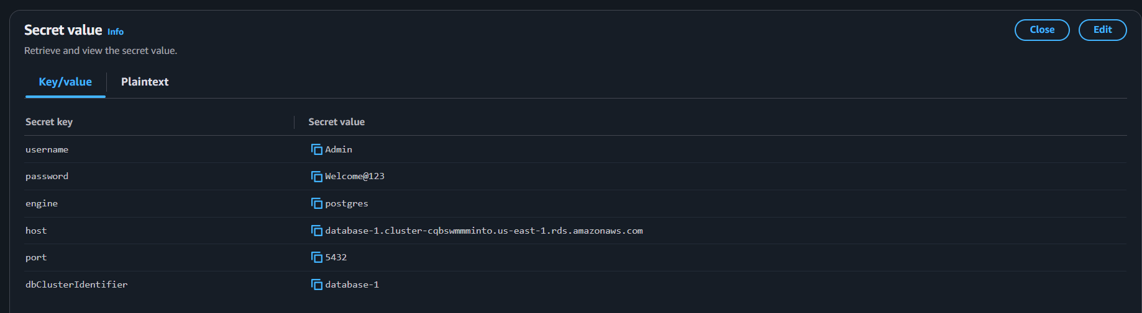

Hands-on 3:
Create Secret Using AWS CLI
aws secretsmanager create-secret \
--name app-secret \
--secret-string '{"username":"admin","password":"Welcome@123"}'

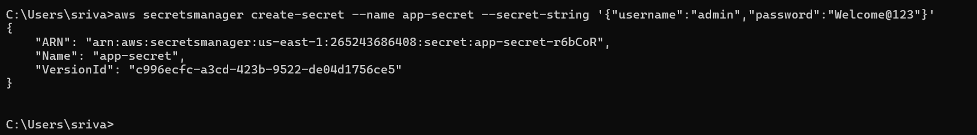

Hands-on 4: List Secrets
aws secrets manager list-secrets
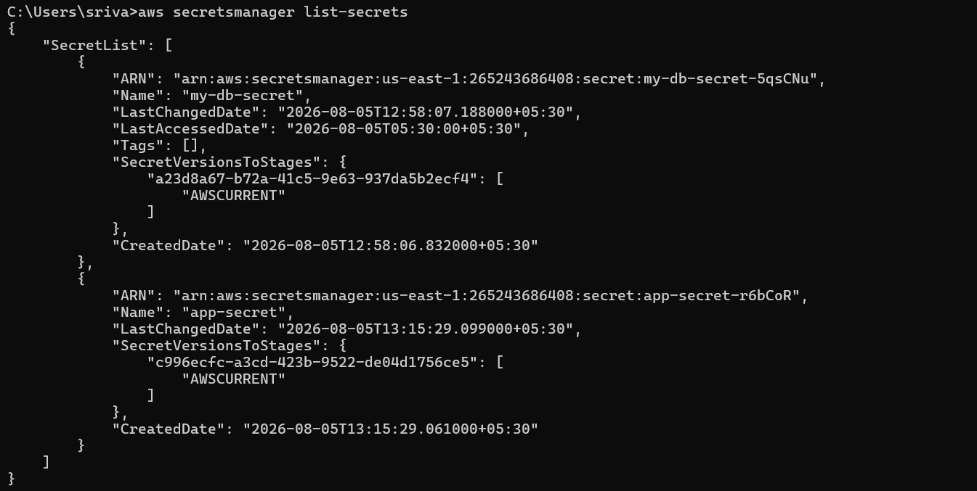

Hands-on 5: Get Secret
aws secretsmanager get-secret-value --secret-id my-db-secret
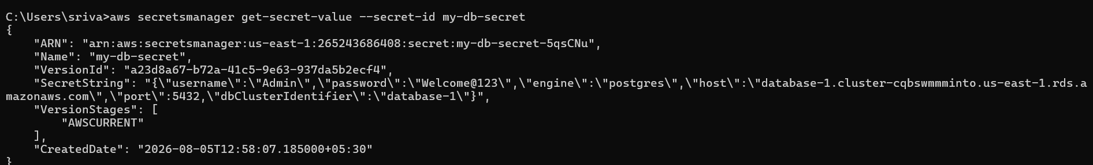

Hands-on 6: Update Secret
aws secretsmanager update-secret \
--secret-id my-db-secret \
--secret-string '{"username":"admin","password":"NewPassword@123"}'
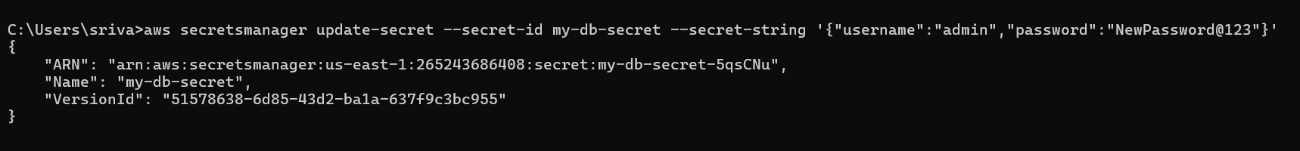
Verify:
aws secretsmanager get-secret-value \
--secret-id my-db-secret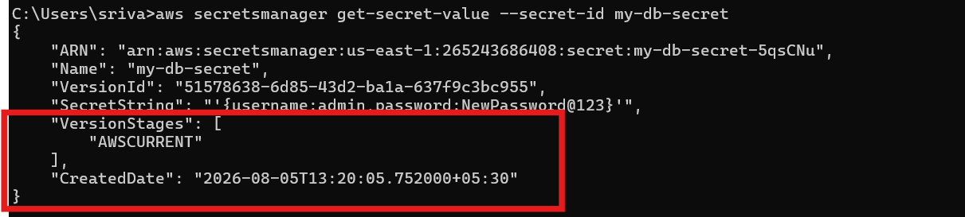

Hands-on 7: Delete Secret
aws secretsmanager delete-secret \
--secret-id my-db-secret
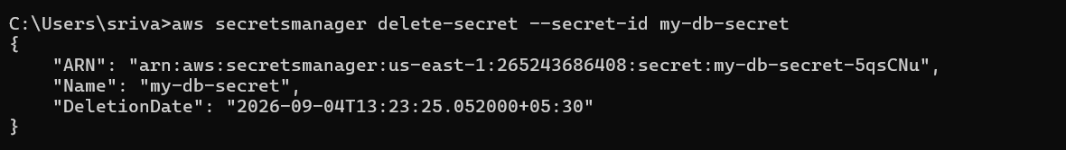

Hands-on 8: Restore Secret
aws secretsmanager restore-secret --secret-id my-db-secret
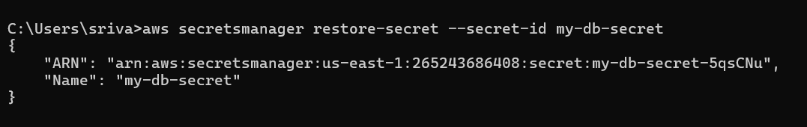

Hands-on 9: Use Secret from EC2
- Launch an EC2 instance.
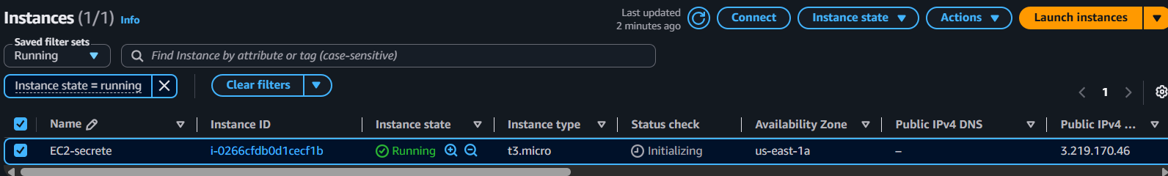
- Attach an IAM role with SecretsManagerReadWrite.
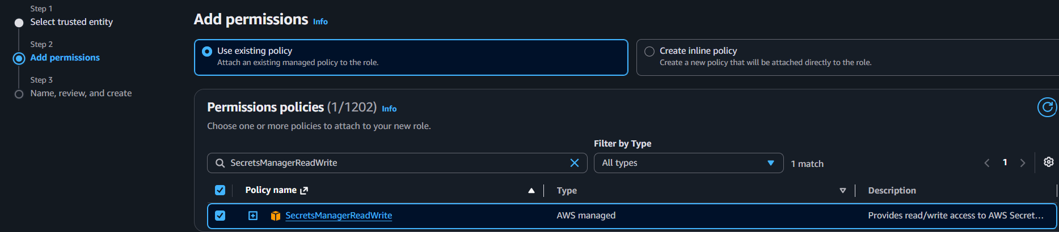
- Connect to the instance.
- Run:
aws secretsmanager list-secrets
aws secretsmanager get-secret-value \
--secret-id my-db-secret
✅ The secret should be displayed.
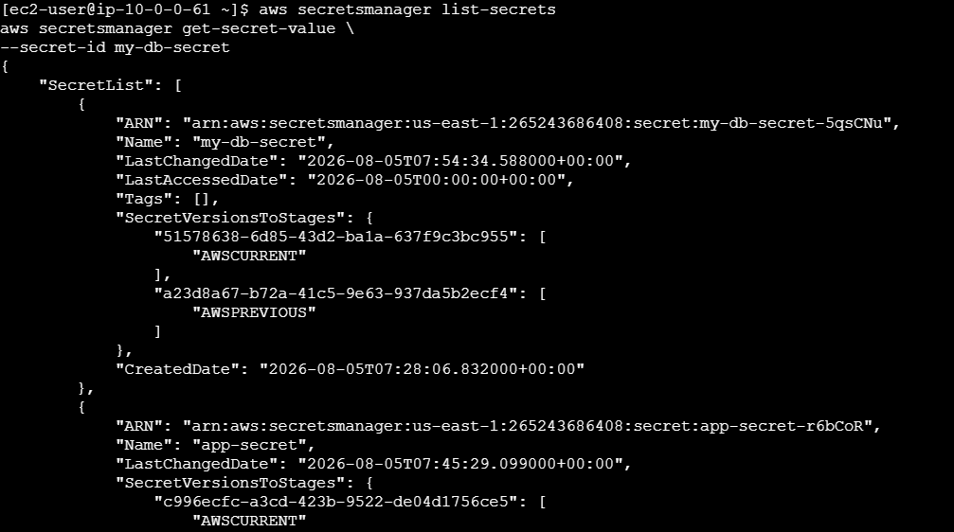

Hands-on 10: Lambda Integration
- Create a Lambda function.
- Attach an IAM role with secretsmanager:GetSecretValue.
- Add Python code to read the secret.
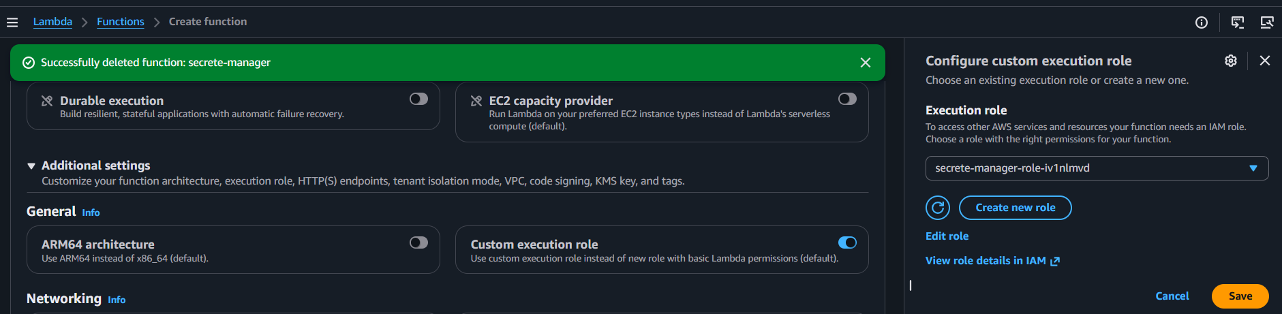
- Deploy and test.
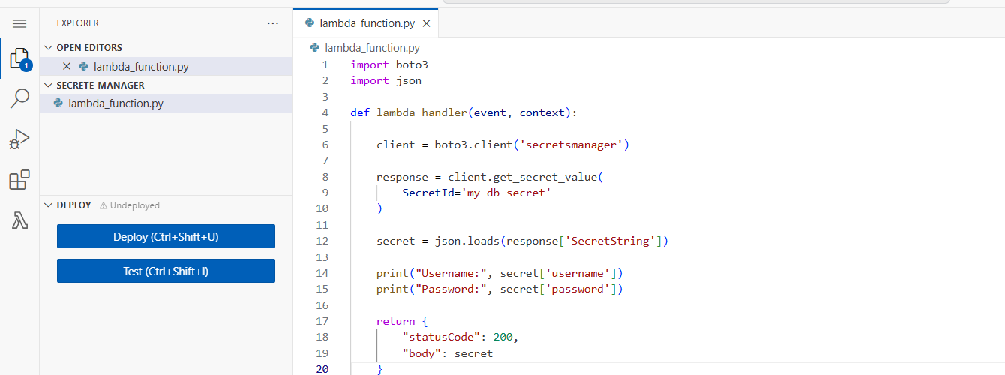
- Verify the output in CloudWatch Logs.
